Writing Managed Applications for the .NET Framework

The .NET Framework simplifies many aspects of programming for Windows. In Visual C++ .NET 2003, you can create Windows applications, Windows services, web services and console applications. When working with the Visual C++ Toolkit, visual designers for Windows Forms are not available, but the full power of the .NET Framework is accessible from C++ code for all kinds of applications. This sample shows just the “tip of the iceberg” for C++ programmers and demonstrates some of the productivity gains that come from using the Base Class Libraries (BCL) that come with the .NET Framework.

The sample is a single C++ module that demonstrates several features of the Base Class Libraries. All C++ code that targets the .NET Framework must include this line:

#using <mscorlib.dll>

This directive ensures that classes in the library contained in mscorlib.dll are available to this module. The classes are contained in a C++ namespace. To reduce typing, this sample, like most C++ programs that target the common language runtime, uses a namespace directive to shorten the names of classes (such as Console) in the System namespace:

using namespace System;

To compile the sample, use this command line:

cl /clr framework.cpp

This compiles with the /clr option, to target the common language runtime, and then links the application. To run framework.exe, just type its name:

framework

Working with XML
Classes that read, write, parse, and transform XML are in the System::Xml namespace. This line makes the classes available:

#using <System.Xml.dll>

Once you have brought in the library with #using, optionally you can reduce the amount of typing with this line:

using namespace System::Xml;

Without this using namespace statement, classes in the namespace must be referred to by their full names, such as System::Xml::XmlDocument. With the using namespace statement, you can use shorter names such as XmlDocument.

This sample code reads a small file of XML and processes it. The XML looks like this:

<?xml version="1.0" encoding="utf-8"?>
<PurchaseOrder>
<Customer id="123"/>
<Item SKU="1234" Price="1.23" Quantity="1"/>
<Item SKU="1235" Price="4.56" Quantity="2"/>
</PurchaseOrder>

The code to process it is:

XmlDocument* xmlDoc = new XmlDocument();
try
{
xmlDoc->Load(S"sample.xml");
Console::WriteLine(S"Document loaded ok." );
XmlNodeList* items = xmlDoc->GetElementsByTagName(S"Item");
double total = 0;
long numitems = items->Count;
for (int i=0;i<numitems;i++)
{
XmlNode* item = items->Item(i);
double price = Double::Parse(item->Attributes->GetNamedItem(S"Price")->get_Value());
double qty = Double::Parse(item->Attributes->GetNamedItem(S"Quantity")->get_Value());
total += price * qty;
}
Console::WriteLine(S"Purchase Order total is ${0}", __box(total));
}
catch (Exception *e)
{
Console::WriteLine(S"problem loading XML");
Console::WriteLine(e->Message);
}

The XML code is in a try block in case the file does not exist or contains XML that is not well-formed. The XmlDocument class supports methods from the DOM API such as GetElementsByTagName(), which returns a pointer to a list of XML nodes. Each node has a property called Attributes, representing an XML attribute, and the attribute has DOM methods such as GetNamedItem(). This code should be readable to anyone who has worked with the XML DOM in any programming language.

The strings from the XML are parsed into doubles and used to calculate a running total. After all the items have been processed, the total is passed to Console::WriteLine(), which writes it on the screen. Because total is of type double, and the managed Console::WriteLine() expects an object reference, total must be boxed with the __box keyword before it is passed to WriteLine().

This portion of the sample produces this output:

Document loaded ok.
Purchase Order total is $10.35

Try editing the XML file and confirming that new entries are processed correctly. Also try running the program when the XML file is missing or is not well formed, or is well-formed but has no <Item> elements.

If You Have Visual Studio
Visual Studio contains a built in XML-editor with syntax coloring and (for documents with associated schemas) Intellisense that provides drop-down choices while editing XML, based on the elements or attributes that are permitted at the edit point. Visual Studio also provides a drag-and-drop visual schema editing tool and a tool to create XML schemas from sample documents or database schemas.

Working with Images
Many developers have purchased libraries for image manipulation. When you target the common language runtime and use the Base Class Libraries, you may be able to meet all your image manipulation needs without deploying a separate library.

To use the Image class, add this line to bring in the library:

#using <System.Drawing.dll>

This line shortens the names of classes in the namespace:

using namespace System::Drawing;

This code reads a JPEG from the hard drive, creates a thumbnail image 100 pixels by 100 pixels, and saves it back to the hard drive:

try
{
Image* image = Image::FromFile(S"largepicture.jpg");
Image* thumbnail = image->GetThumbnailImage(100,100,0,0);
thumbnail->Save(S"thumbnail.jpg",
Imaging::ImageFormat::Jpeg);
Console::WriteLine(S"Thumbnail created");
}
catch (Exception* e)
{
// out of memory exception thrown for bad format
Console::WriteLine(S"Image file not found or invalid format");
Console::WriteLine(e->Message);
}

The code is in a try block in case the file does not exist or does not contain a valid JPEG image. This is how simple it is to work with image files (GIFs, JPEGs, or bitmaps) with the Base Class Libraries.

Working with the Event Log
The event log is a convenient way to record results when an application has no user interface, or when the results to be recorded are not just for the user’s immediate needs. Errors and warnings often appear in the event log, along with tracking messages from services and other applications that do not have a user interface.

To use the EventLog class, add this line to bring in the library:

#using <System.dll>

This line shortens the names of classes in the namespace:

using namespace System::Diagnostics;

This code writes an entry to the event log:

try
{
if (! EventLog::SourceExists(S"SDKSample") )
EventLog::CreateEventSource(S"SDKSample",
S"SDKSampleLog");
EventLog::WriteEntry(S"SDKSample",S"The sample has been run.",
EventLogEntryType::Information);
Console::WriteLine(S"Event logged");
}
catch (Exception* e)
{
Console::WriteLine(S"problem creating or writing to event log");
Console::WriteLine(e->Message);
}

This code might fail if the log does not exist and the user who runs the sample is not an administrator. The try and catch block will catch this problem.

After running the sample, view the Event Log by following these steps:
- Right-click the My Computer icon and choose Manage, or navigate to Start, Programs, Administrative Tools, Computer Management
- Expand System Tools, then Event Viewer
- Select the SDKSampleLog node
- In the righthand pane, double-click any message to view it

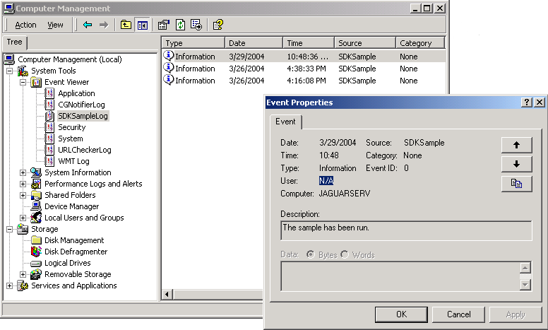

The node under Event Viewer (SDKSampleLog in this case) is determined by the second parameter to CreateEventSource(), the log name. The Source of the log entries (SDKSample in this case) is set by the first parameter to CreateEventSource() and used to identify the log where the event will be written with WriteEntry(). The third parameter to WriteEntry() controls the severity: an enumeration called EventLogEntryType has the values Error, FailureAudit, Information, SuccessAudit, and Warning. The Event viewer displays the associated symbols automatically.

If You Have Visual Studio
Event logs can also be viewed from within Visual Studio, in the Server Explorer pane. This view shows the message without your having to open the log entry.

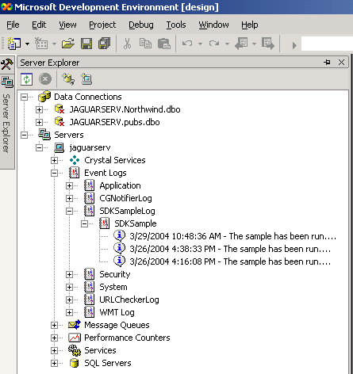

Summary
Keep in mind that the sample code shown here can be deployed with “copy-and-run” (also called XCopy deployment): simply copy the .exe file to a machine with the .NET Framework installed and run the executable. There is nothing to register or install. The file of XML and the image file should be in the same folder as the executable.

More information and documentation pertaining to the .NET Framework is here:

http://msdn.microsoft.com/library/default.asp?url=/library/en-us/netstart/html/sdk_netstart.asp

